**Escape the Sussy Gussy Store Rooms**

**GAME DESIGN DOCUMENT**

**Game Overview**

**What is the Game About?**

Player has to run from an unknown entity named Bryan while attempting to steal back the Los Pollos Hermanos chicken recipe which he stole before escaping.

**Game Theme**

Horror

**Game Genre**

Maze game

**Game Platform**

PC

**Game Story**

Bryan the racist SCP stole Gustavo Fring’s chicken recipe and Gus has hired you to steal it back.

**Target Audience**

Everyone

**ART**

**Characters**

**Hero Characters**

**Villain Characters**

**NPC (Non Playable Characters)**

|  |  |  |  |  |
| --- | --- | --- | --- | --- |
| **N.O** | **Name of Character** | **Type** | **About the Character** | **Abilities** |
| **1** | **Bryan**  C:\Users\student\Desktop\Storerooms_groupProject\Assets\bbryan.png | Villain | More about the character that in relation to the game play and game story | What are the character’s abilities |

**Environments**

|  |  |  |  |  |
| --- | --- | --- | --- | --- |
| **N.O** | **Name of Region** | **Levels** | **About the Region** | **Enemies** |
| **1** | Albuquerque, New Mexico | 1 | Bryan’s territory | Bryan |

**UI DESIGN**

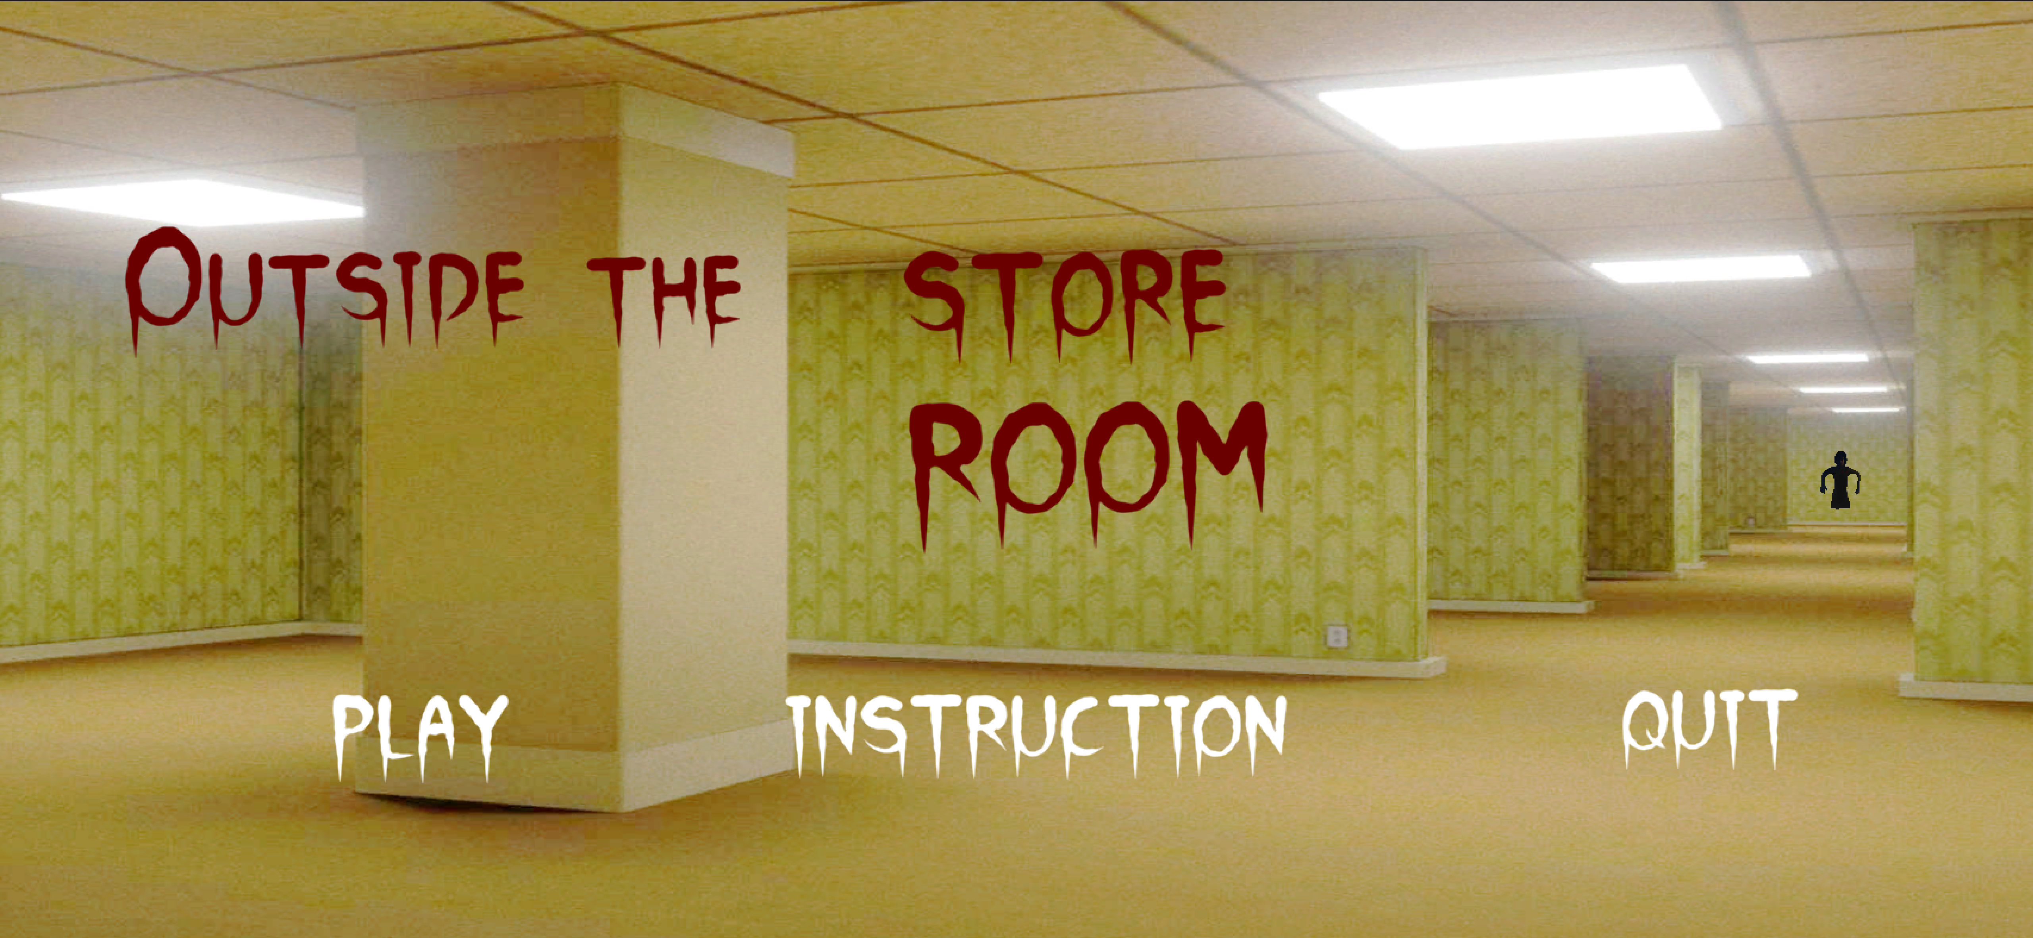

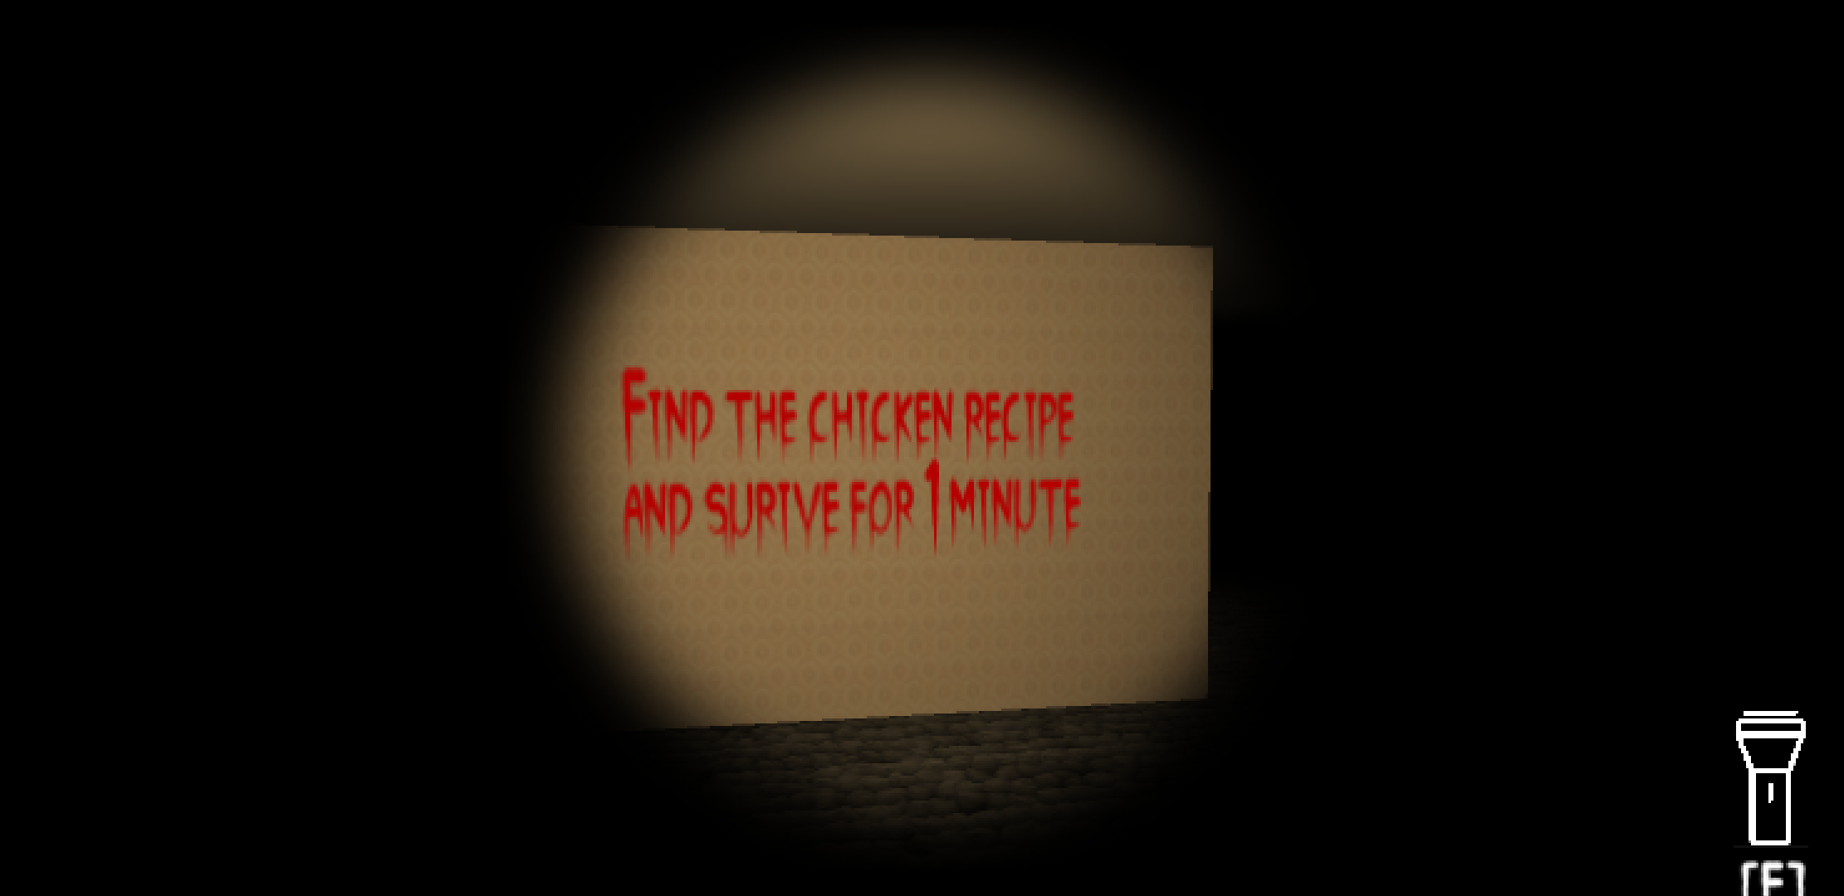

**DESIGN**

**LEVEL DESIGN**

|  |  |  |  |  |
| --- | --- | --- | --- | --- |
| **N.O** | **Region** | **About the Level** | **Objectives of the Level** | **Challenges of the Level** |
| **1** | Store rooms | Maze | 1. Steal the Chicken Recipe 2. Find the exit | 1. Enemy 2. Time Limit (3 mins) |

**SOUND DESIGN**

**Background Sound**

BG Sound 1 : To be played when player is running from Bryan (Intense)

BG Sound 2: To be played when player is exploring the store rooms

**Sound Effects**

Discuss the main sound effects to be used for the game

Sound FX 1: Bryan voice lines

Sound FX 2(GIMME BACK MY RECIPE): After escaping this audio will play

**PROGRAMMING**

**GAME SYSTEMS**

Once you reach the exit, Bryan will scream gimme back my recipe.

**GAME MECHANICS**

After collecting the Los Pollos Hermanos recipe, Bryan will spawn.

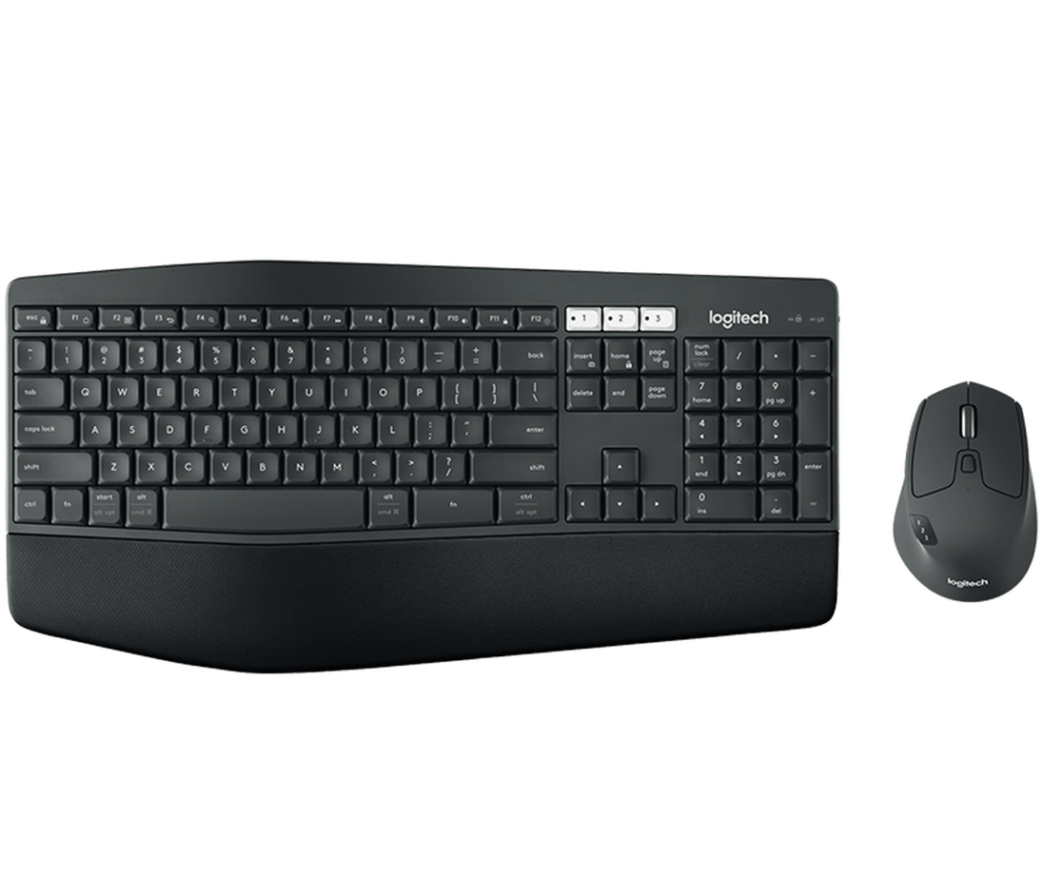

Left Click: Fire 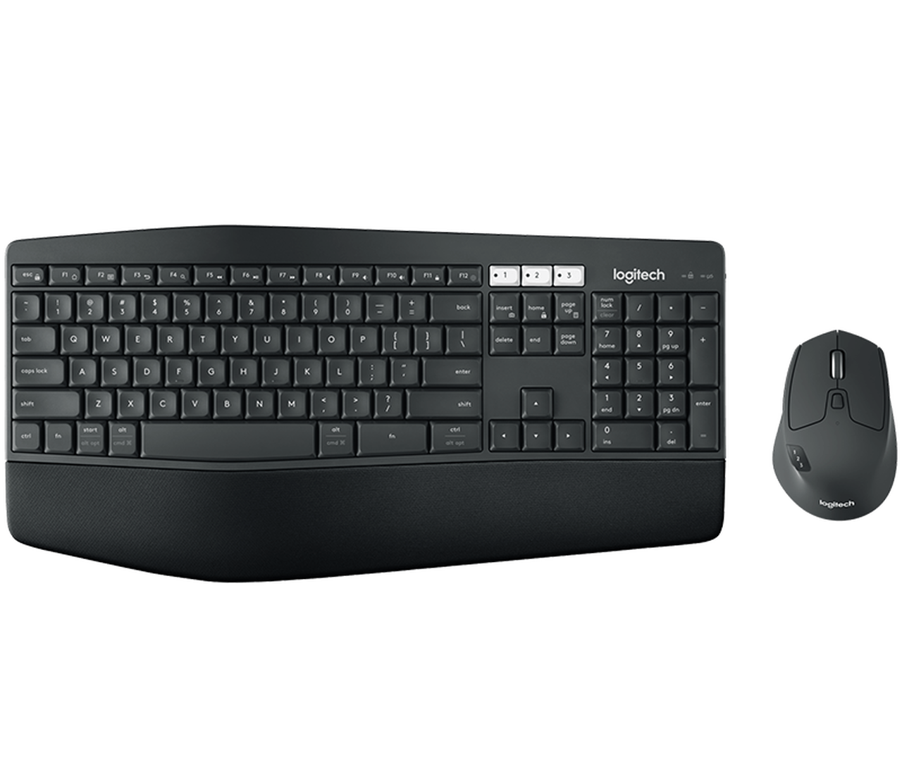: Fire

Space Bar: Jump

**Performance Test**

**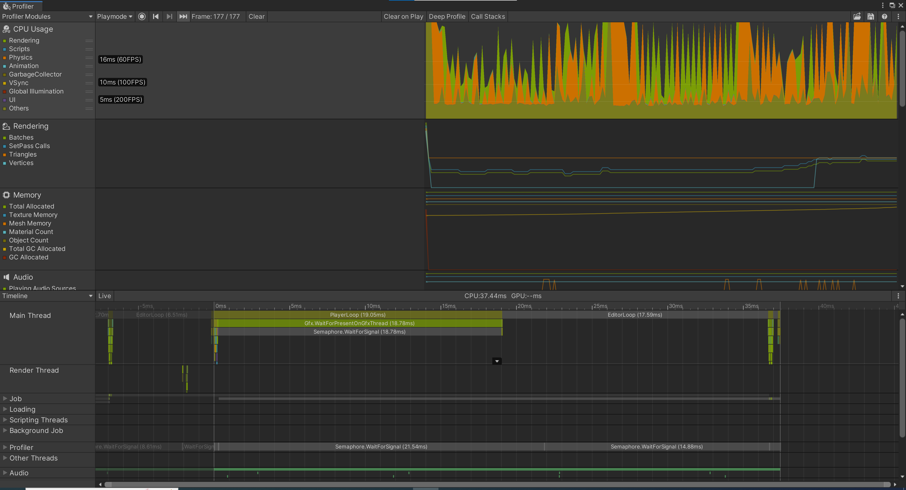**

**Gant Chart**

**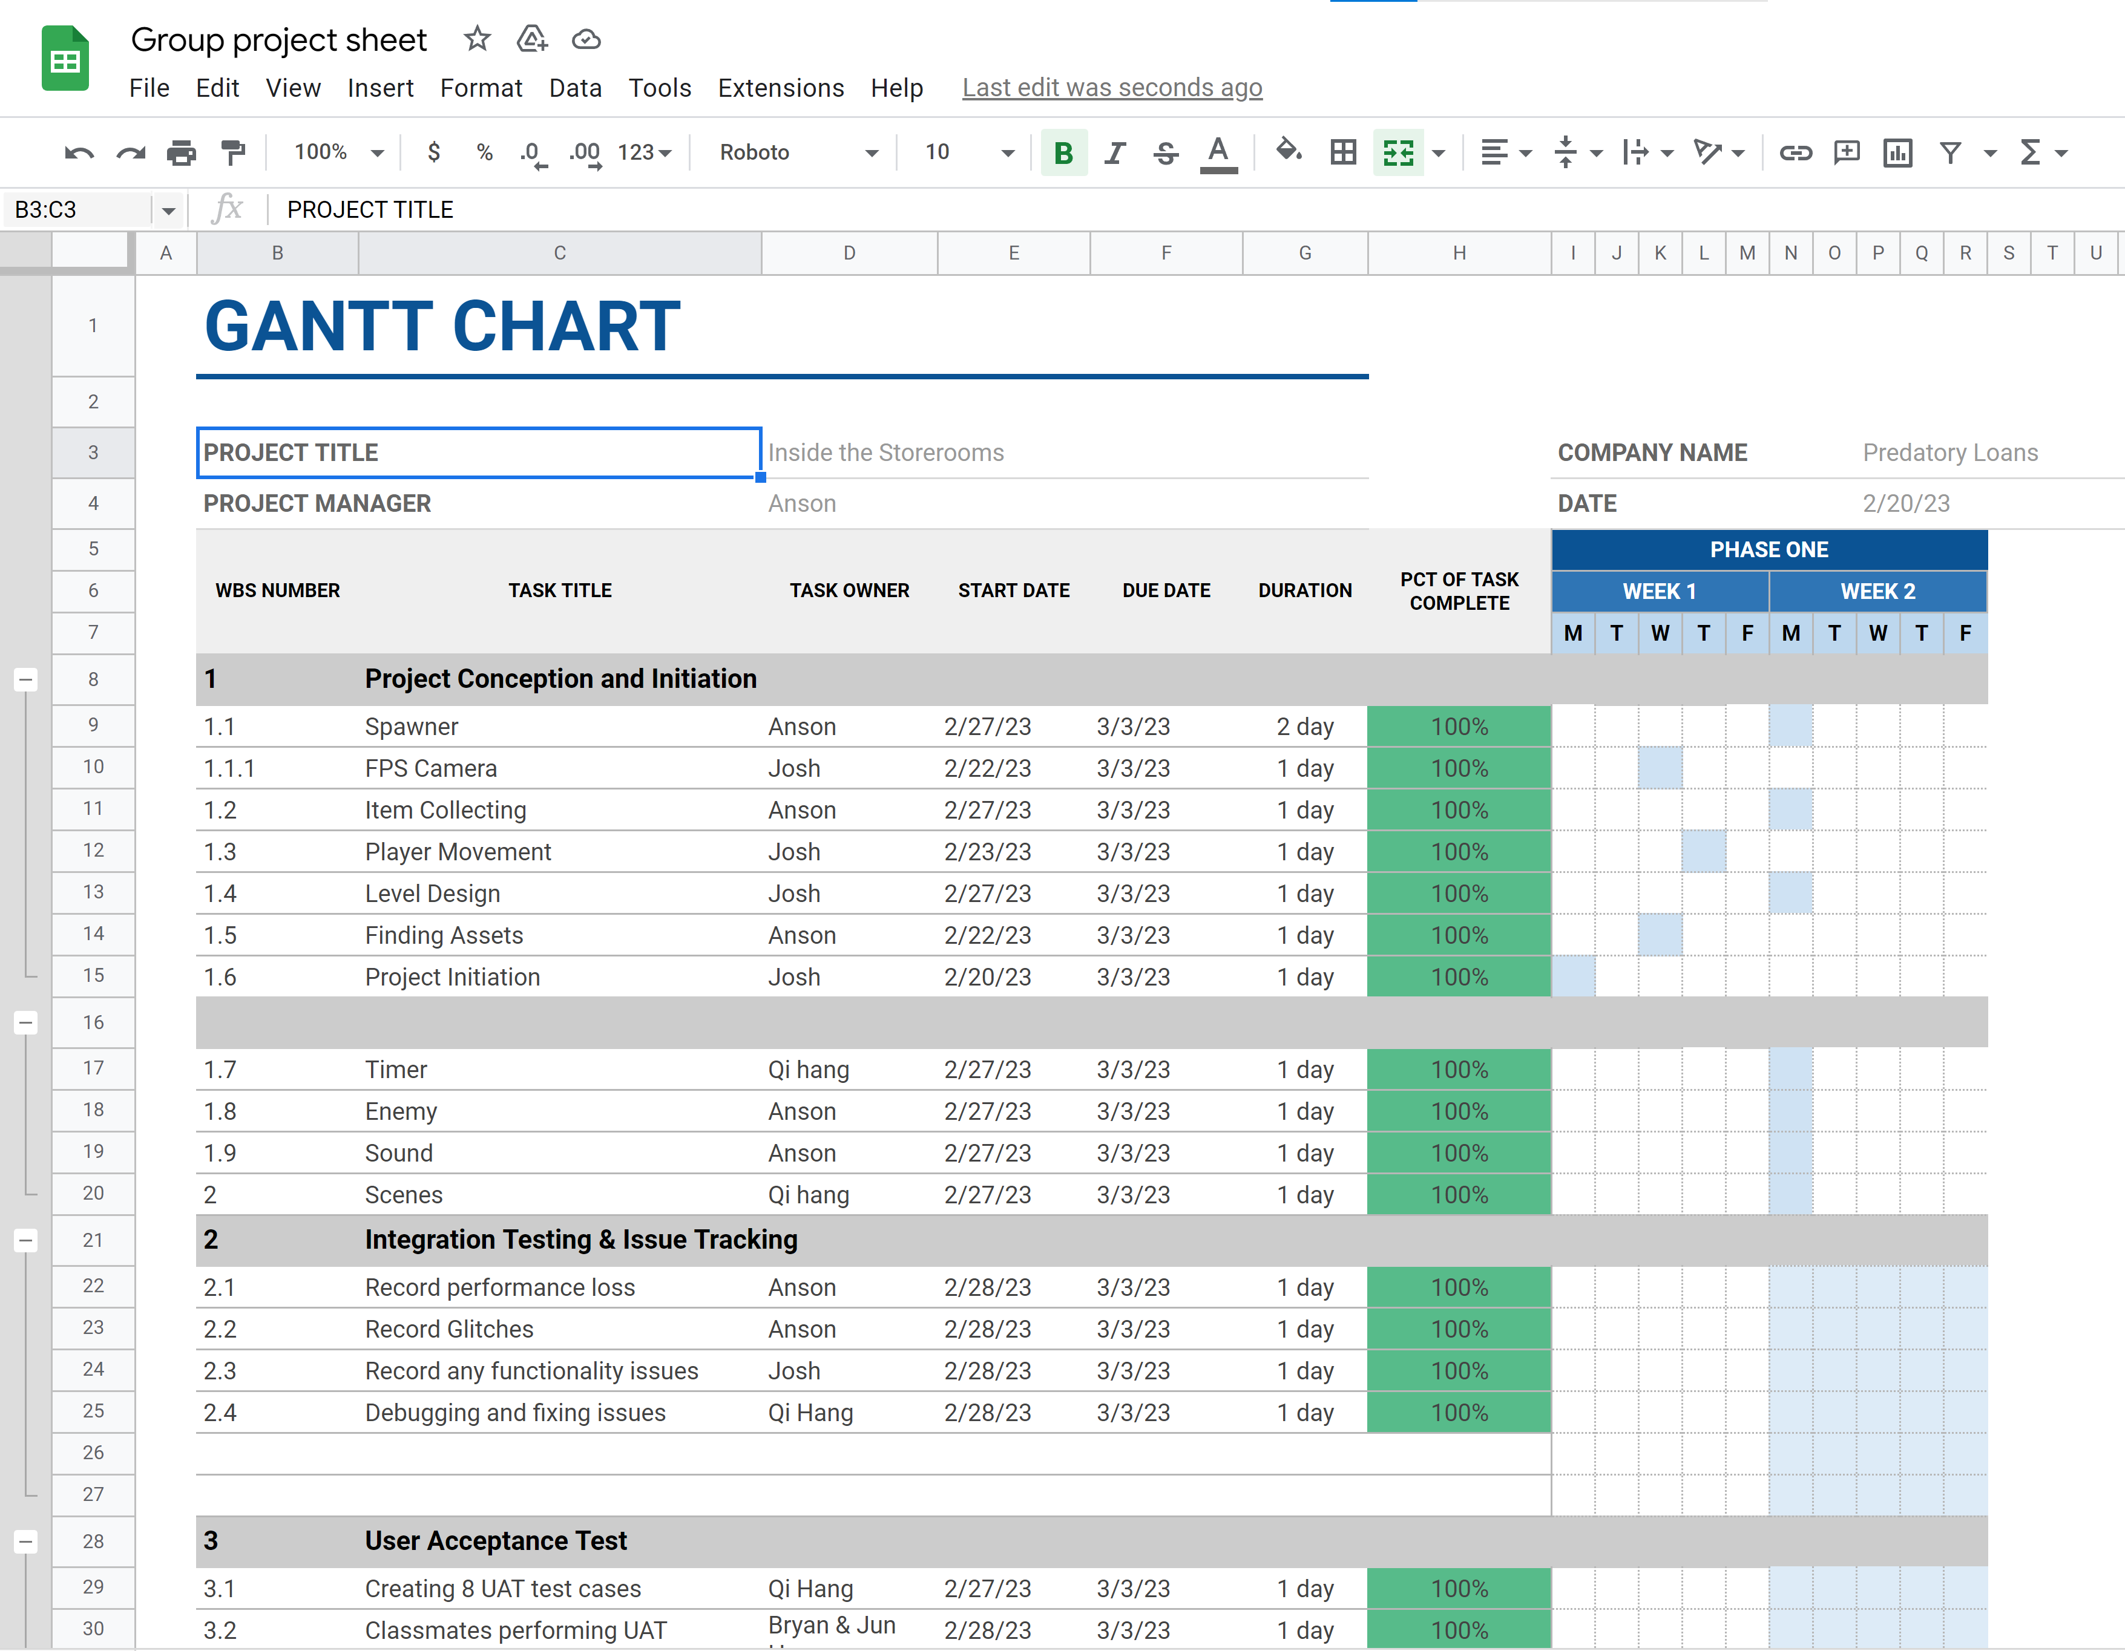**

**Code Optimization**

* Constant Propagation
* Extract Method

**Links:**